**Name: Balraj**

**ID: 3157523**

**Title: Seed Management System**

**Task 1 - Identify the problem**

**Call Discussion with Client: Babal**

**Information of the client:** Received a call from Babal, a seed businessman wants to develop a software for his business from me as he is facing problem in keeping record of his business and also to promote his business online, he is looking for a software for his business moreover he want SEO and mobile friendly website that should open in any mobile and tablet as per the requirements

**Primary objective of the project:** Babal is in the seed business. But he is facing huge losses due to mismanagement of the seeds needed. As the records are manual, it causes redundancy and even are difficult to manage, so he needs a proper software to minimise his losses and make his business profitable by reducing the damages or by knowing what actually is needed, how much is needed, for whom it is needed and during which season it is needed.

**Requirement of The Software**

Scope of Work

Features of the Website: Client want responsive website that should have mobile Capability and with good speed.

**Functional Requirements: Demanded requirements by end user: -**

Babal needs a software which is customer friendly and even he can access the software easily.

* He needs the usage of GUI maximum to make the software look good and user friendly. As his clients are very particular about their seeds,
* He needs the seeds information to be defined clearly on the software. Even he needs a proper cart and checkout system for his software, so that someone can buy seeds online.
* He wants the software to show him the amount of seeds left in the inventory and which seeds are much in demand and which are not.
* He also wants the system to inform him about the ongoing changes in the environment, so that he can pre plan his seeds storage accordingly.
* He also wants the customers to have a login ids maintained so that they can keep the records of what was ordered, and and what price it was ordered.

**Non-functional requirements:**

* + He want SEO properly in the site so that his site should be visible on every platform i.e. Google and other also
  + Overall Performance should be good.

**Time:** It will take minimum 20 days to complete. We will create the project based on SDLC Model. We are defining the full milestone as under below:

|  |  |  |  |
| --- | --- | --- | --- |
| **Id** | **Description** | **Completing days** | |
| **Plan** | **Actual** |
|
| 1 | Planning | 2 hrs | 2 hrs |
| 2 | Requirements analysis | 4 hrs | 4 hrs |
| 3 | Software Designing | 6 hrs | 6 hrs |
| 4 | Software Development | 6 hrs | 6 hrs |
| 5 | Software Testing | 01 hrs | 01 hrs |
| 6 | Deployment | 01hrs | 01 hrs |

The 4 essential steps of the Risk Management Process are:

1. Risk Identification: Risk can come anytime like Covid-19 and at this time no focus is no anything which arises to many other risks such as no communication , depression stress and many more
2. Scope: During the risk the only scope should be calm and positive and always focus to the work
3. Resolve the problems we should find the middle way to solve the problems such as communication on skye and Zoom can be better option at this time.
4. Not all risks can be eliminated – some risks are always present. Market risks and environmental risks are just two examples of risks that always need to be monitored. Under manual systems monitoring happens through diligent employees.

Cost: We will charge $1200. But we will charge in different-2 instalments after completing the tasks. Which I am defining under:

|  |  |  |
| --- | --- | --- |
| **Id** | **Tasks** | **Payment** |
| 1 | Completing Planning and Requirements | $200 |
| 2 | Completing Designing | $200 |
| 3 | Completing coding third Module | $200 |
| 4 | Completing coding fourth module | $200 |
| 5 | Completing Testing and implementation | $200 |
| 6 | Completing the changes found in Testing | $200 |

**Project management:-** I got this idea of making Gantt chart from YouTube as they shown in a video and really it helped me a lot in managing the tasks easily and i can easily have an idea about the dates of working .

While making the project this technique of Project management worked well for me from planning with client to having the requirements of the website and then coding the website.

**Gantt Chart:**

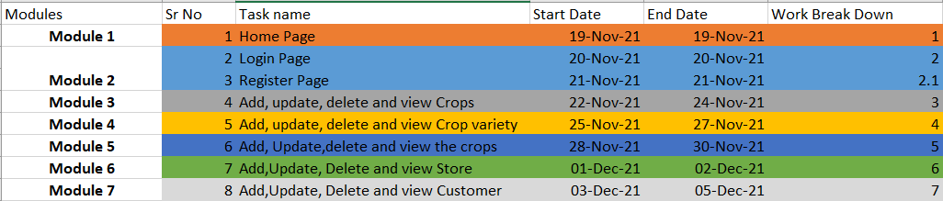

**Link:** [**GanttChart.xlsx**](GanttChart.xlsx)

**Task 3 - Design mockups**

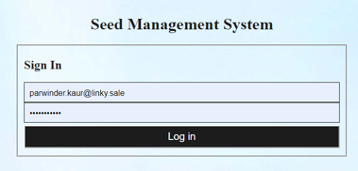

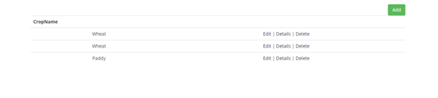

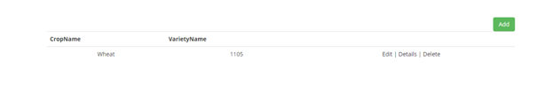

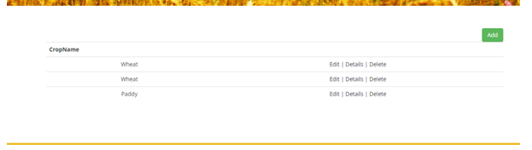



|  |  |
| --- | --- |
| **Module** | **Colour** |
| Login form | Yellow, blue and black |
| Menu bar | Blue and white |
| Forms and tables | White and black |

## Task 5- usability testing

**own task**

1. **Task 1- could be ask user to add a new variety of crop**
2. **Task 2 – add Crop Variety**
3. **Task 3 – Create crop price list**
4. **Task 4 – Add bank Payment details**
5. **Task 5 – Add Project Internship**

**User details -**

**User 1 – Male 42 yrold , farmer, no comuting skills**

**user 2 – Female 22 yr old, student**

**user 3 – Boy 26 year old, farmer**

**Result Summary**

|  |  |  |  |  |
| --- | --- | --- | --- | --- |
| **user** | **Task 1** | **Task 2** | **Task 3** | **Task 4** |
| **User 1** | **Completed** | **Not completed** | **Completed** | **Completed** |
| **User 2** | **Completed** | **Completed** | **Completed** | **Completed** |
| **User 3** | **Worked (Completed)** | **Completed** | **Not Completed** | **Completed** |

**Task 6 - Meet with your client**

Client Meeting:

|  |
| --- |
| Meeting Details |
| * Date and time: 25-Oct-2021 * Location: Newzealand |
| Attendees: Balraj and Babal |
| Agenda: Discussion of Software of Seed management system |
| Discussion (Important Points): He wants neat and clean software which will work effectively |
| My To Dos (Actions): Firstly I have to make the mockups of the application. Then Starting the application after the next meeting. |
| Questions requiring Follow- Up: Discussion of the mock ups |
| Comments: Jatin is good person and he described regarding software very wisely. |
| Next meeting  Date and Time: 1- Nov-2021 1:00 Pm  Location: Newzealand  Agenda: Showing the mock ups to the client and discussion about further development. |

**Appendix 3**

**Client Review Form**

My developer’sname: Balraj

This form is intended to let you review the communication skills of your developer for this assignment. Your review will partly count towards their final mark. Do not take into account technical skills.

# Grading scale

You must grade your developer for each item listed in the tables below. 1 being the lowest, 5 the highest.

|  |  |  |  |  |
| --- | --- | --- | --- | --- |
| **1** | **2** | **3** | **4** | **5** |
| Strongly disagree | Disagree | Ok | Agree | Strongly agree |

# Review your developer

|  |  |  |
| --- | --- | --- |
| **Item** | **Grade** | **Comment** |
| Communicated clearly and effectively | 2 |  |
| Kept you informed of the progress | 5 |  |
| Met timelines | 3 |  |
| Responded promptly to problems | 4 |  |
| Met overall project objectives | 2 |  |
| Was open to new ideas and suggestions | 4 |  |
| Was easy to work with | 5 |  |

Comments

Provide any extra comments on your developer’s communication skills and professionalism.

Balraj is good person and has professenalism.

## Signed by Client

|  |  |
| --- | --- |
| **Signature: Babal** | **Date: 14-nov-2021** |
| **Name:Babal** | **Title:Seed Management System** |
| **Contact details (email/Tel):** | |

S

Screenshots

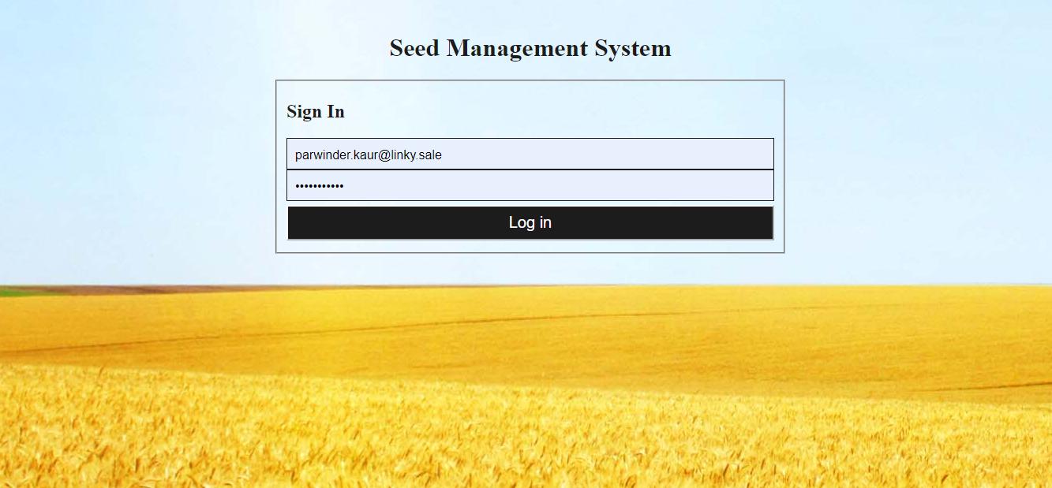.

This is login screen for Seed management system. This can be login by different roles in the system.

2. This screen is the landing page while login into the system.



1. This screenshot is to maintain details of crops.

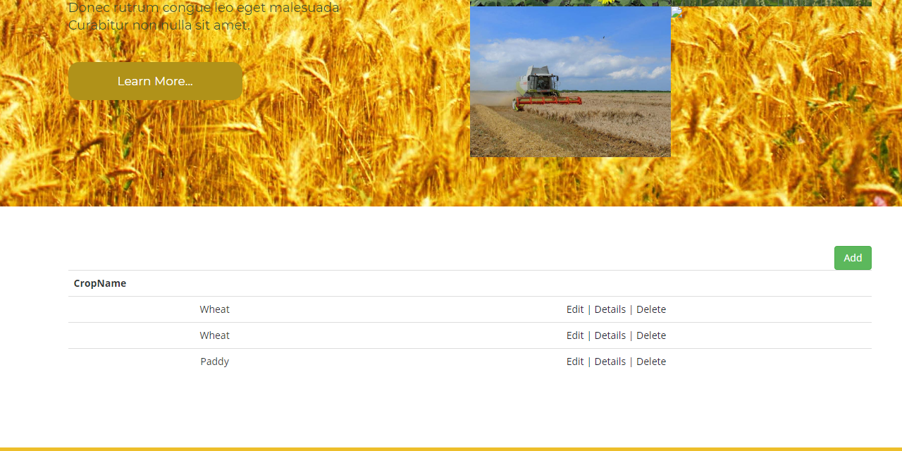

1. Crop Screen



1. Crop Variety Screen

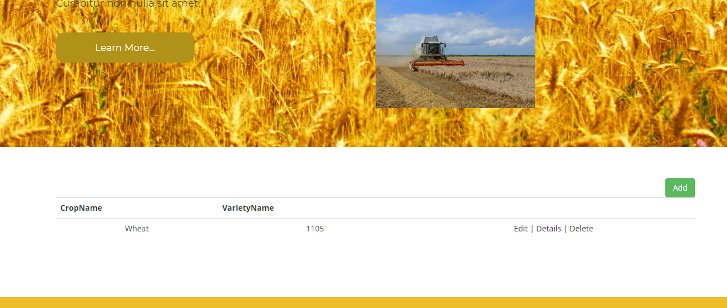

1. Create Crop Variety

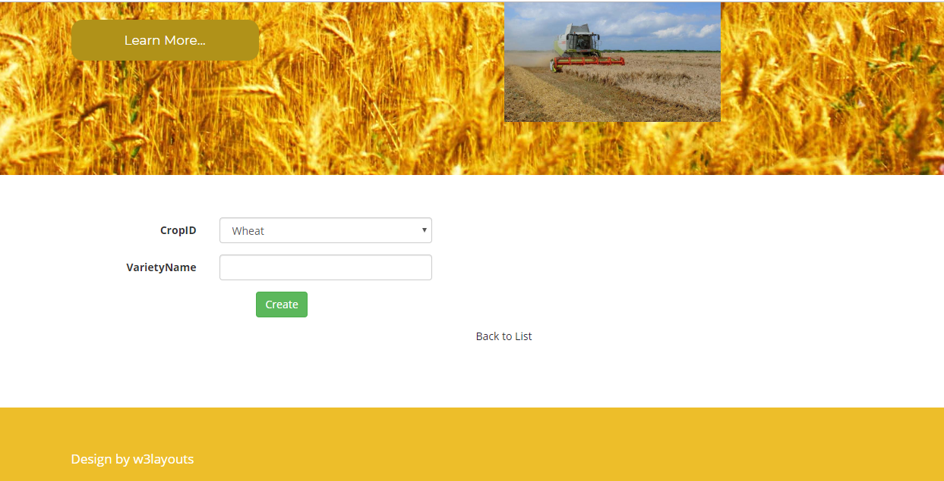

1. Crop Rate List Screen

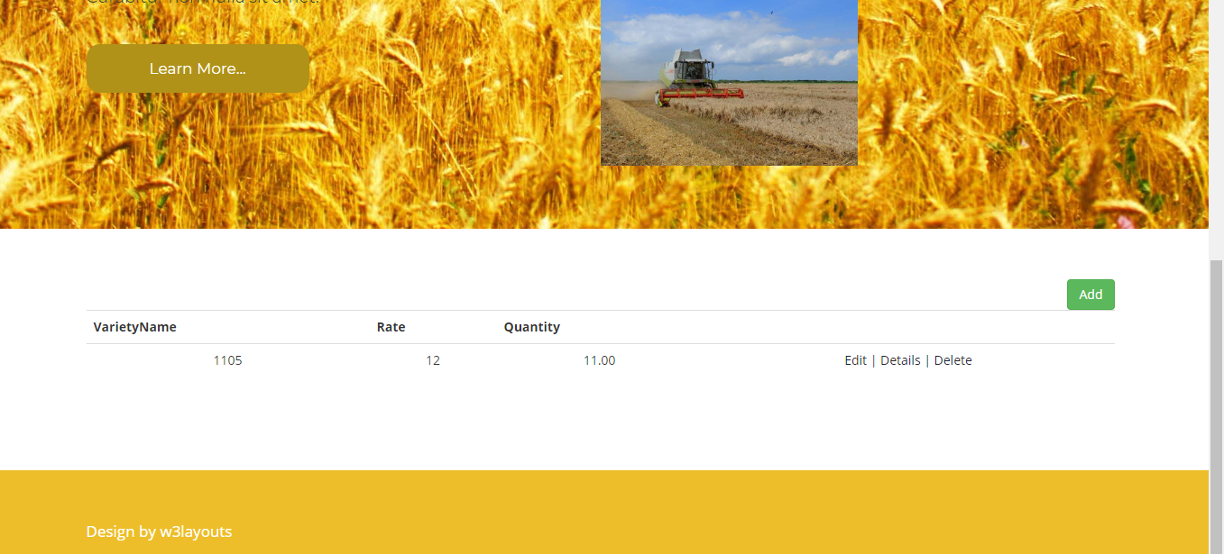

8. Edit Crop Rate

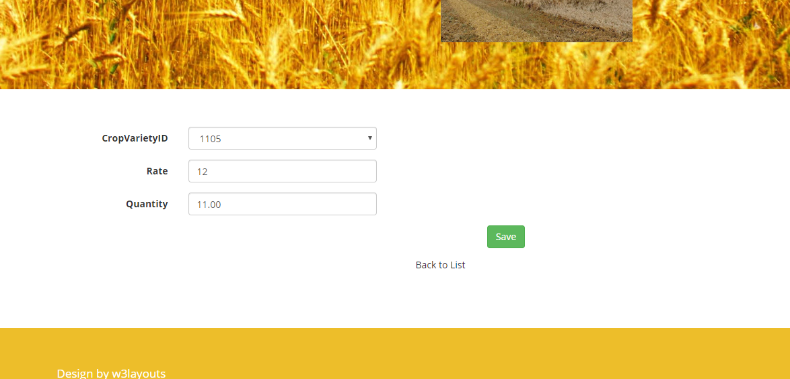

9. Store List

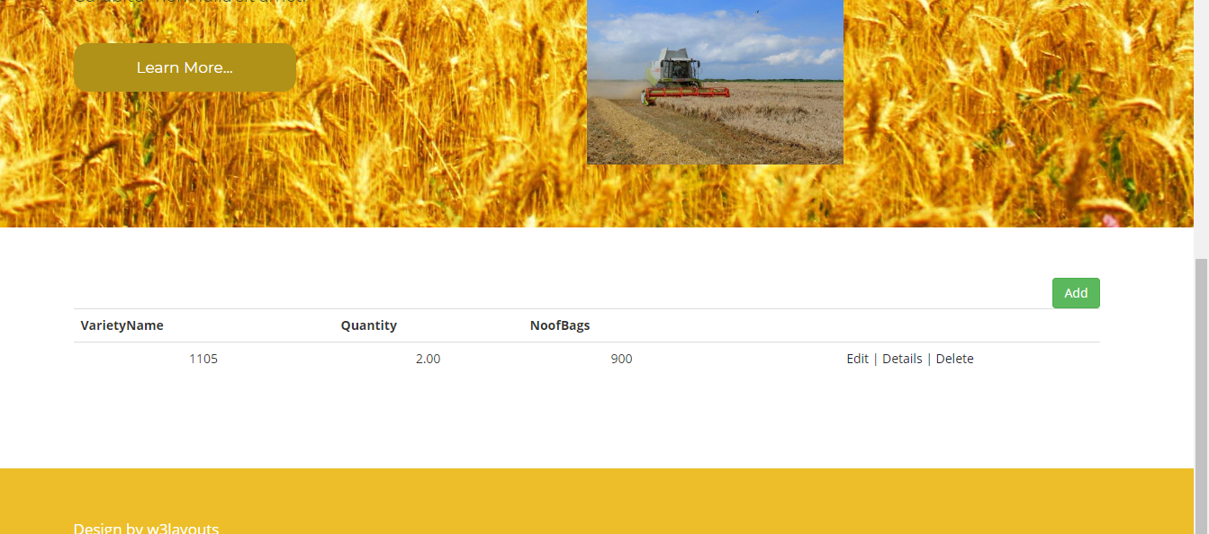

10. Create Store List

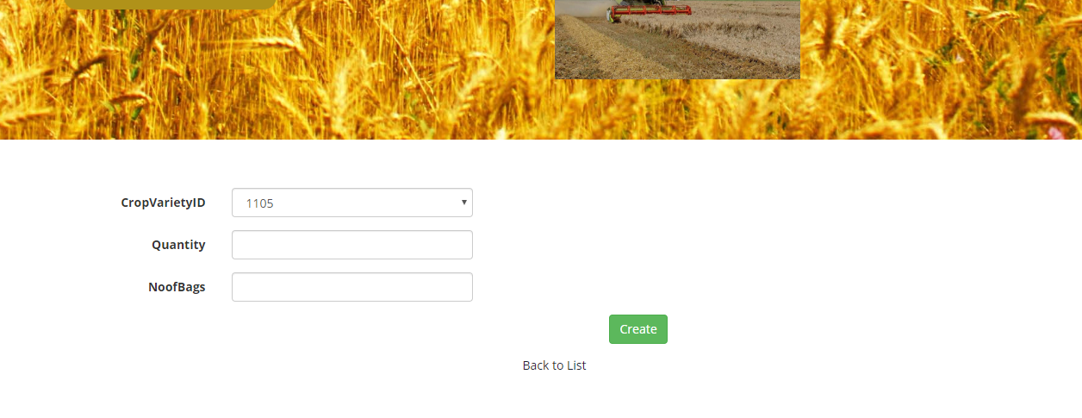

11. Customer List

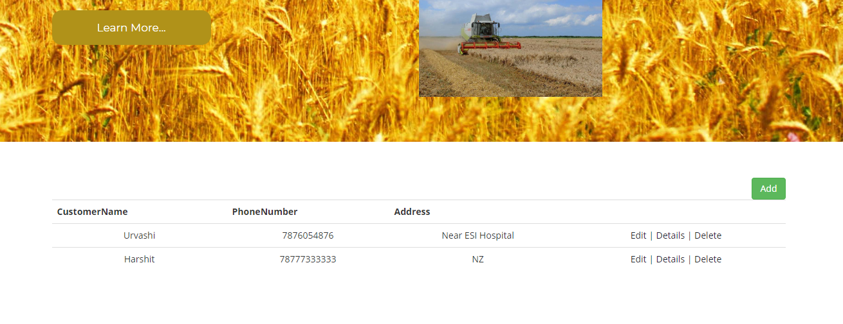

12. Edit Customer

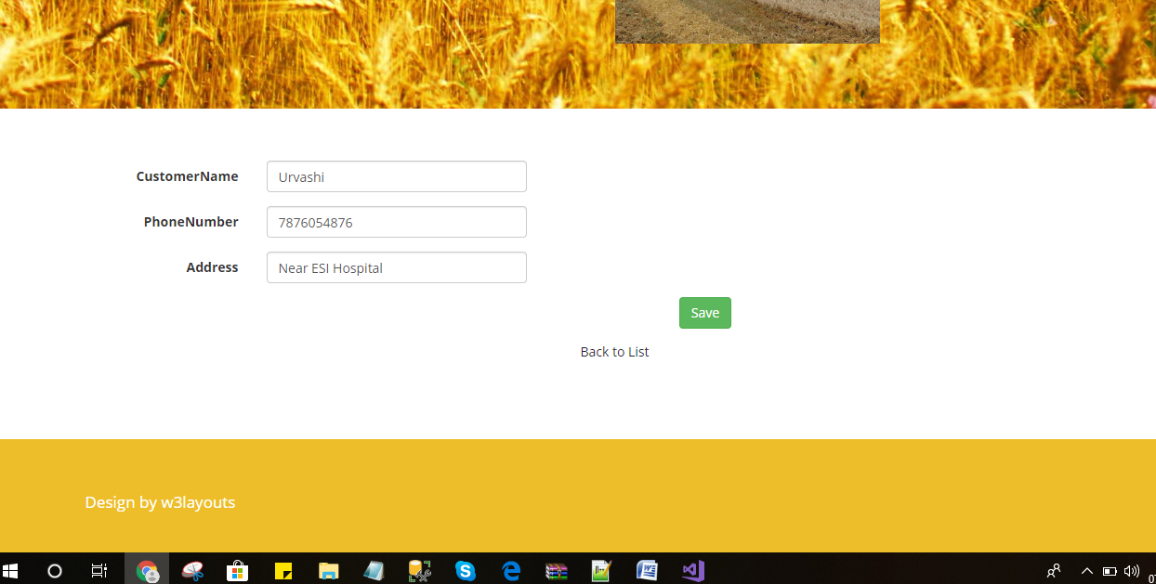

13. Seed Selling List

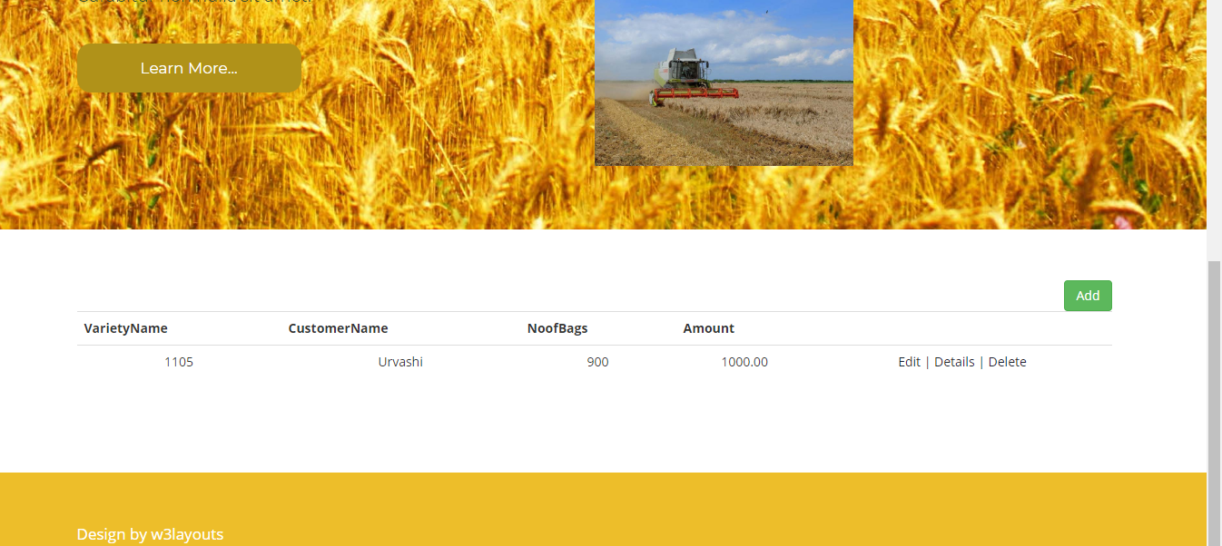

14. Create Seed Selling Record Screen

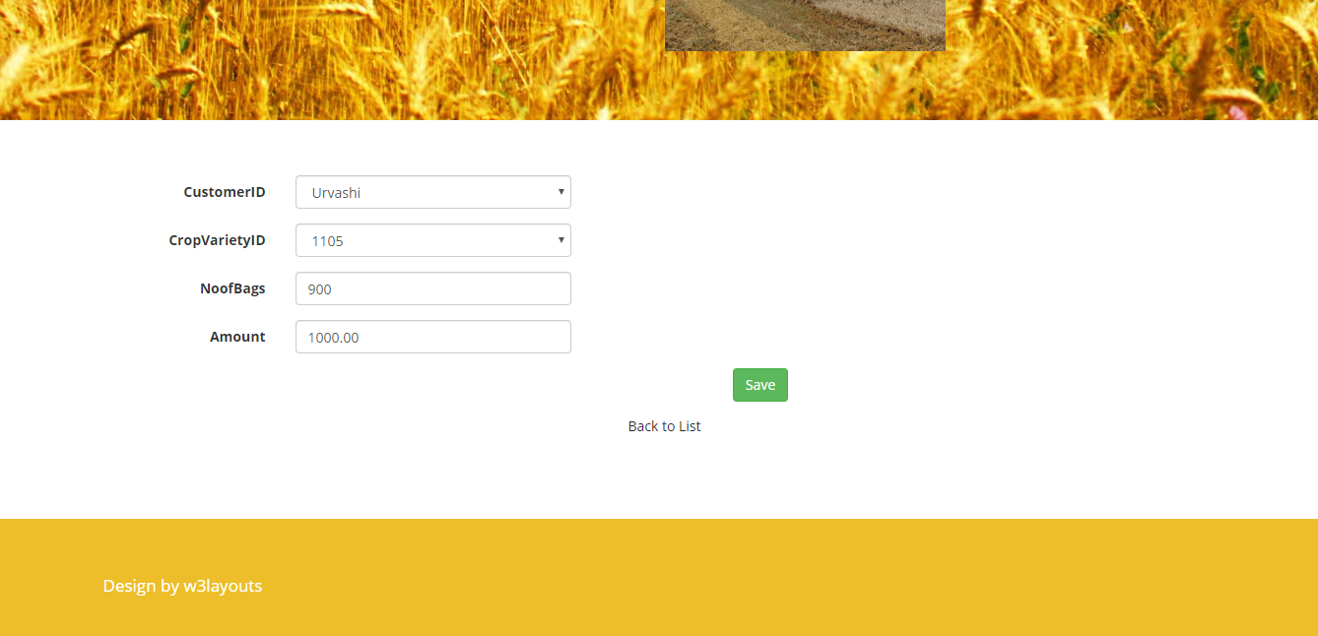

15. Bank Payment List

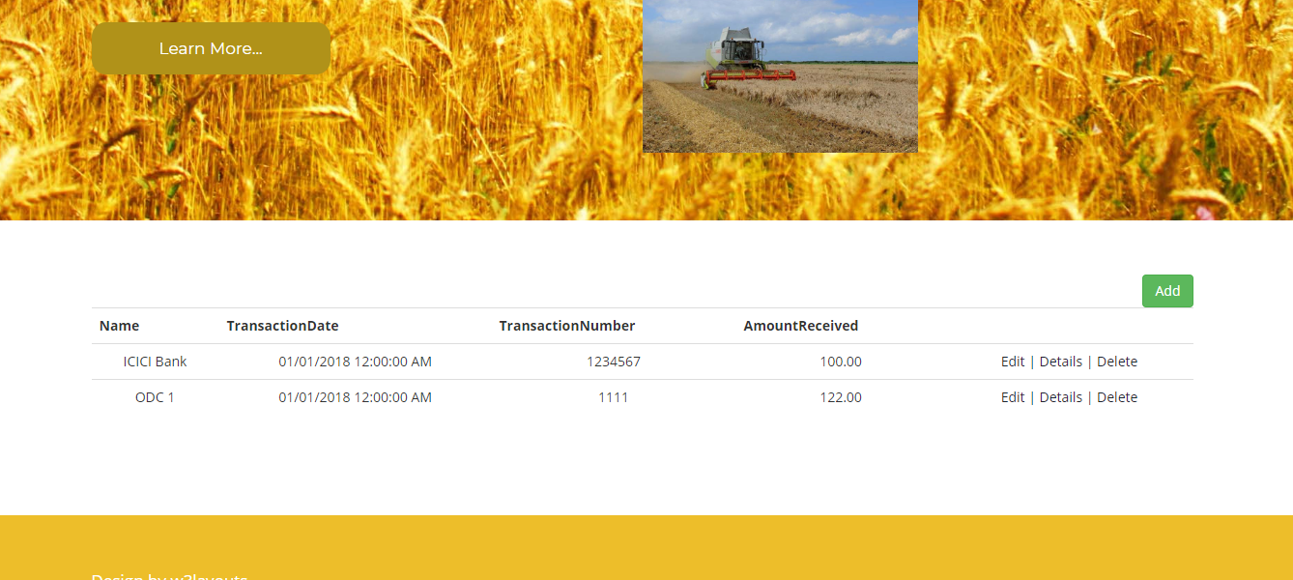

18. Bank Payment Create Screen

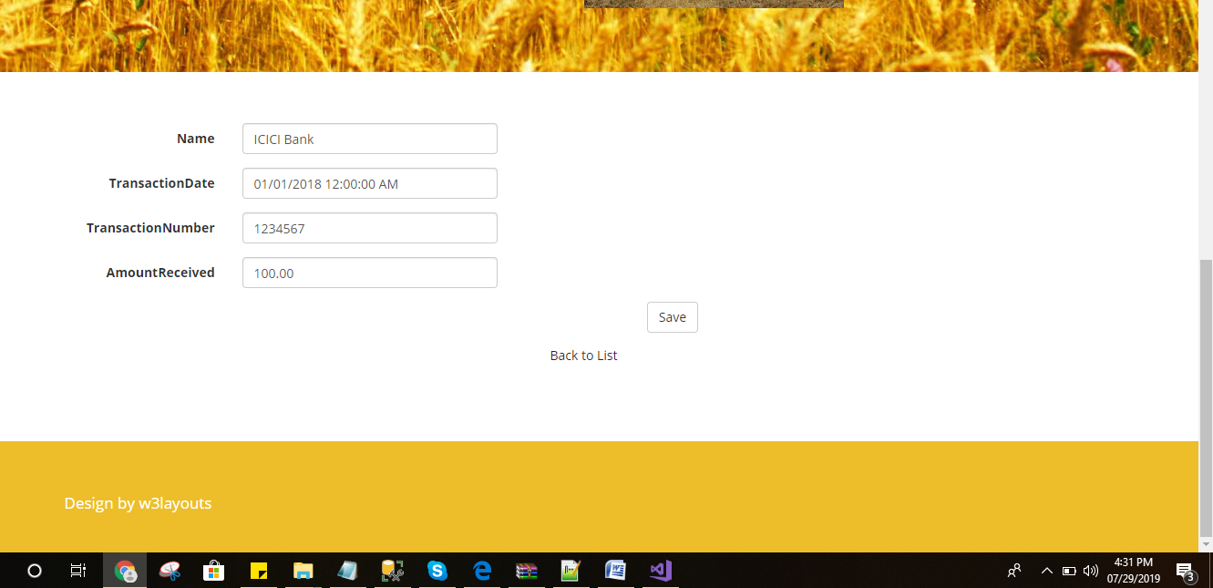

**Task 8 - Software development life cycle stages**

**Planning :-** The planning phase of the SDLC is also when the project plan is developed that identifies, prioritizes, and assigns the tasks and resources required to build the structure for a project. With that said, this step culminates in a detailed project plan and with the help of planning with working becomes very easy and helped me a lot in maintain the work flow

**Requirement: -** The most important phase of the SDLC is the requirement gathering and analysis phase because this is when the project team begins to understand what the customer wants from the project. After the project team receives all of the customer requirements or specifications, the team begins to analyze each requirement and taking requirement comes in first stage of development that means gathering the information that is needed

**Software Design and prototyping:-**

The Prototyping Model is one of the most popularly used Software Development Life Cycle Models (SDLC models).This model is used when the customers do not know the exact project requirements beforehand. In this model, a prototype of the end product is first developed, tested and refined as per customer feedback repeatedly till a final acceptable prototype is achieved which forms the basis for developing the final product.

**Software Development:-**This is the actual writing of the program. A small project might be written by a single developer, while a large project might be broken up and worked by several teams. Use an Access Control or Source Code Management application in this phase. These systems help developers track changes to the code. They also help ensure compatibility between different team projects and to make sure target goals are being met.

**Testing:** The testing phase of the software development lifecycle (SDLC) is where you focus on investigation and discovery. During the testing phase, developers find out whether their code and programming work according to customer requirements. for building a software testing is very important it help t create a polished product with Quality of work.

**Task 9- Project management**

Project management is the application of processes, methods, skills, knowledge and experience to achieve specific project objectives according to the project acceptance criteria within agreed parameters. Project management has final deliverables that are constrained to a finite timescale and budget.

Principles I have followed for creating my project:-

1. I have Created clear and concise project goals.
2. I have Managed risks.
3. I have Established a performance baseline.
4. I have Established and maintained healthy communication.

.

Success : Completing the project was the biggest success because completing something after a huge hard work is a kind of success that matters a lot and motivate very much in the life.

Weakness: Fear of losing was the biggest weakness of me as i think if this will what would be the conscious

Lessons Learn : I learn one lesson for life after completing this project is focus that with focus we can learn and do anything

Project helped me lot throughout the project as it improved the quality of coding and maintaining the project.

Project management is the science and art of organizing all the components of a project. For example, the launching of a new service, a marketing campaign, or the development of a new product are projects. In fact, even a wedding is a project that requires management.